**TITLE**

**Name: Optimal Path Finder Using Reinforcement Learning**

**Version: 1.0v**

**Date: 18/02/2020**

**INTRODUCTION**

**Reinforcement Learning (RL) is a machine learning technique that deals with the problems of finding the optimum actions that must be done in a given situation in order to maximize rewards.**

**This learning technique, which is inspired by behavioral psychology, is usually described as follows. An agent in any environment makes certain movements in this environment and gains rewards as a result of these movements. The main aim is to maximize the total reward and learn the optimal policy for the longest range.**

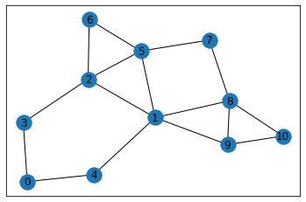

**I want to find shortest path from 0 to 10. I need to attract walks to edges involving 10, therefore I give these actions high reward. In networkx library, G[node] gives all nodes which form an edge with the node.**

**I set all rewards 0 except the actions arriving node 10. These actions are going from 8 to 10 or 9 to 10. Like Rewards, Q-values are initialized in a matrix. To eliminate impossible actions, their Q-values are set -100. For example, in the graph, it is not possible to go directly from 2 to 10, therefore its Q-value set as -100. Possible actions are initialized as 0.**

**REQUIRMENTS**

**Recommended System Requirements**

**1.Windows, Linux and Mac**

**2.Ram 2Gb or Above (tested on 4Gb)**

**3.500MB or Higher of Hard disk Space**

**Recommended Software Requirements**

**1.Install Python**

**2.Install Jupyter NoteBook**

**CONFIGURATION**

**Open the Command Prompt and use the pip Command to install the following libraries:**

**1.matplotlib (pip install matplotlib)**

**2.networkx (pip install networkx)**

**3.pandas (pip install pandas)**

**4.numpy (pip install numpy)**

**INSTALLATION**

**Extract to short paths like C:/User or D:/User (using any Zip extractor software)**

**Open “Optimal Path Finder Using Reinforcement Learning.ipynb” in Jupyter NoteBook and run it in there.**

**CODE**

import matplotlib.pyplot as plt

import networkx as nx

import pandas as pd

import numpy as np

import random

%matplotlib inline

def learn(er,lr,discount):

for i in range(50000):

start = np.random.randint(0,11)

next_node = next_number(start,er)

updateQ(start,next_node,lr,discount)

learn(0.5,0.8,0.8)

**VERSION**

**1.0v**

**CONTACT INFORMATION**

**Email: faizan@rapsitech.com**